1.INTRODUCTION
Thyristor controlled series compensation (SSSC) can change the reactance of transmission line flexibly to modulate power flow, and is one of the most efficacious means to improve the stability of power system. Low frequency oscillation (LFO) in large scale interconnected network is a key problem which debases system stability. To the united inter connected network in China, the use of SSSC to damping LFO has more and more important theory significance and engineering values.
The transient stability control strategy has been discussed in many papers, in which some Controllers with complex structure are give out. But some field experience indicated that the oscillation frequency and the phase shift angle of the controller have a great influence on the damping to power oscillation, which is a problem with very little study. This paper carries out a research of the control strategy of SSSC to improve transient stability in multi-machine network, and give the base control rules of SSSC to damp power oscillation quickly, and illuminates the relationship between system dynamic performance and phase shift angle.
The Benefits of Flexible AC Transmission Systems (FACTs) usage to improve power systems stability are well known. The growth of the demand for electrical energy leads to loading the transmission system near their limits. Thus, the occurrence of the LFO has increased. FACTs Controllers has capability to control network conditions quickly and this feature of FACTs can be used to improve power system stability. The SSSC is a FACTS device that can be used to the LFO. The primarily use of SSSC is to control the power flow in power systems. The SSSC consists of two voltage source converters (VSC) each of them has two control parameters namely me, δe ,mb and δb . The SSSC used for power flow control, enhancement of transient stability, mitigation of system oscillations and voltage regulation.

1.1 Facts Controllers
The simulations of various FACTS (Flexible alternating current transmission system) devices have been done using MATLAB/SIMULINK software. These FACTS devices are (FC-TCR, STATCOM, TCSC, SSSC, and UPFC) are controlled by controlling their source and line impedance value. First we determined the impedance value for better system performance. By varying the value of capacitor of all the above FACTS device models real and reactive power flow through the system is tabulated to find the FACTS device which gives better performance for a particular capacitor value.

1.2 Definitation Of Facts
Flexible AC Transmission Systems, called FACTS, got in the recent years a well known term for higher controllability in power systems by means of power electronic devices. Several FACTS-devices have been introduced for various applications worldwide. A number of new types of devices are in the stage of being introduced in practice.
In most of the applications the controllability is used to avoid cost intensive or landscape requiring extensions of power systems, for instance like upgrades or additions of substations and power lines. FACTS-devices provide a better adaptation to varying operational conditions and improve the usage of existing installations. The basic applications of FACTS-devices are:
• Power flow control,
• Increase of transmission capability,
• Voltage control,
• Reactive power compensation,
• Stability improvement,
• Power quality improvement,
• Power conditioning,
• Flicker mitigation,
• Interconnection of renewable and distributed generation and storages.
Figure shows the basic idea of FACTS for transmission systems. The usage of lines for active power transmission should be ideally up to the thermal limits. Voltage and stability limits shall be shifted with the means of the several different FACTS devices. It can be seen that with growing line length, the opportunity for FACTS devices gets more and more important.
The influence of FACTS-devices is achieved through switched or controlled shunt compensation, series compensation or phase shift control. The devices work electrically as fast current, voltage or impedance controllers. The power electronic allows very short reaction times down to far below one second.
The development of FACTS-devices has started with the growing capabilities of power electronic components. Devices for high power levels have been made available in converters for high and even highest voltage levels. The overall starting points are network elements influencing the reactive power or the impedance of a part of the power system. Figure 1.2 shows a number of basic devices separated into the conventional ones and the FACTS-devices.
For the FACTS side the taxonomy in terms of 'dynamic' and 'static' needs some explanation. The term 'dynamic' is used to express the fast controllability of FACTS-devices provided by the power electronics. This is one of the main differentiation factors from the conventional devices.
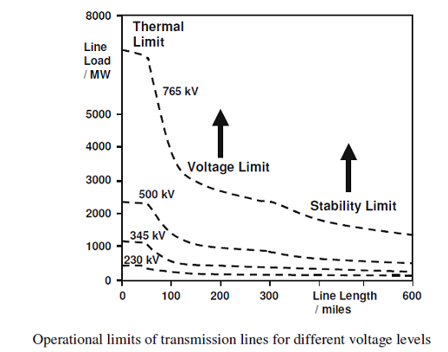
Fig 1.1 Operational limits of transmission lines for different voltage levels
The development of FACTS-devices has started with the growing capabilities of power electronic components. Devices for high power levels have been made available in converters for high and even highest voltage levels. The overall starting points are network elements influencing the reactive power or the impedance of a part of the power system. Figure shows a number of basic devices separated into the conventional ones and the FACTS-devices.
For the FACTS side the taxonomy in terms of 'dynamic' and 'static' needs some explanation. The term 'dynamic' is used to express the fast controllability of FACTS-devices provided by the power electronics. This is one of the main differentiation factors from the conventional devices.

1.3. Types Of Facts Controllers
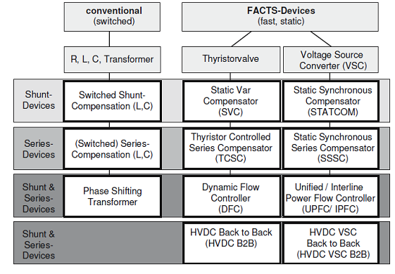
The left column in Figure contains the conventional devices build out of fixed or mechanically switch able components like resistance, inductance or capacitance together with transformers. The FACTS-devices contain these elements as well but use additional power electronic valves or converters to switch the elements in smaller steps or with switching patterns within a cycle of the alternating current. The left column of FACTS-devices use Thyristor valves or converters. These valves or converters are well known since several years. They have low losses because of their low switching frequency of once a cycle in the converters or the usage of the Thyristors to simply bridge impedances in the valves.
The right column of FACTS-devices contains more advanced technology of voltage source converters based today mainly on Insulated Gate Bipolar Transistors (IGBT) or Insulated Gate Commutated Thyristors (IGCT). Voltage Source Converters provide a free controllable voltage in magnitude and phase due to a pulse width modulation of the IGBTs or IGCTs. High modulation frequencies allow to get low harmonics in the output signal and even to compensate disturbances coming from the network. The disadvantage is that with an increasing switching frequency, the losses are increasing as well. Therefore special designs of the converters are required to compensate this.(thyristor controlled reactor) through a step-down transformer. The rating of the reactor is chosen larger than the rating of the capacitor by an amount to provide the maximum lagging vars that have to be absorbed from the system. By changing the firing angle of the thyristor controlling the reactor from 90° to 180°, the reactive power can be varied over the entire range from maximum lagging vars to leading vars that can be absorbed from the system by this compensator.
In general, FACTS Controllers can be divided into four categories:
1. Series controllers
2. Shunt controllers
3. Combined series-series controllers
4. Combined series-shunt controllers
1.4. Series Controllers
A series controller could be variable impedance such as capacitor reactor or power electronics based variable source of main frequency, sub synchronous and harmonic frequencies (or a combination) to serve the desired need. In principle, all series controllers inject voltage in series with the line. Even variable impedance multiplied by the current flow through it, represents an injected series voltage in the line.
Different types available are as follows:
- Static Synchronous Series Compensator (SSSC)
- Interline Power Flow Controller (IPFC)
- Thyristor-Controlled Series Reactor (TCSR)
- Thyristor-Switched Series Reactor (TSSR)
- Thyristor-Controlled Series Capacitor (TCSC)
- Thyristor-Switched Series Capacitor (TSSC)
1.5. Shunt Controllers
In principle all shunt Controllers inject current into the system at point of connections. Even variable shunt impedance connected to the line voltage causes a variable current flow and hence represents injection of current into the line.
Different types available listed below.
- Static Synchronous Compensator (STATCOM)
- Static Synchronous Generator (SSG)
- Static Var Compensator (SVC)
- Thyristor Controlled Reactor (TCR)
- Thyristor Switched Reactor (TSR)
- Thyristor Switched Capacitor (TSC)
- Static Var Generator (SVG)
1.6. Combined Series-Series Controllers
This could be a combination of separate series controllers, which are controlled in a coordinated manner in a multiline transmission system. The real power transfer ability of the unified series-series controller, referred to as interline power flow controller, makes it possible to balance both the real and reactive power flow in the lines thereby maximize the utilization of the transmission system.

1.7 Combined Shunt-Series Controller
This could be a combination of separate series and shunt controllers, which are controlled in a coordinated manner or UPFC with the series and shunt elements. In principle, combined shunt and series controllers inject current into the system with the shunt part of the controller and voltage in series in the line with the series part of the controller. When series and shunt controllers are unified, there can be a real power exchange between the series and shunt controllers via the power link. Different types are listed below.
- Unified Power Flow Controller (UPFC)
- Thyristor-Controlled Phase Shifting Transformers (TCPST)
1.8 Symbols For Facts Controllers
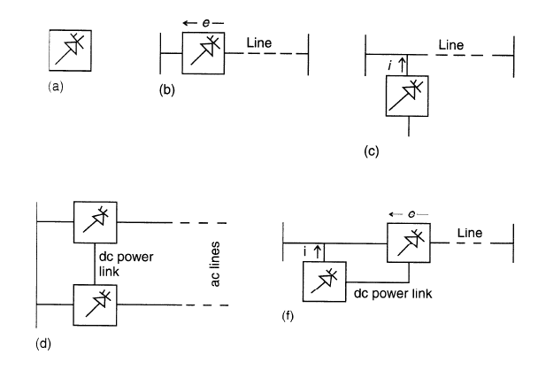
Fig 1.2 Symbols for facts controllers
- General symbol for a FACTS Controllers
- Series controller
- Shunt controller
- Combined series-series controller
- Combined shunt-series controller
2.LITERATURE REVIEW
Renjie Ding, Jun Zhang, Yong Min, Zhiqiang Shi, Haitao Song And Yuwei Zhao presented the design and implementation of a new kind of FCTCR controller based on multiprocessor and digital phase shift triggers which are helpful for controlling the harmonics in a transmission system by reducing the reactive power in order to improve the power quality and provides dampen power swing, reduce system losses and control active and reactive power flow.
Hence it is concluded that SVC (Static VAR Compensator) will successfully control the dynamic
performance of power system and voltage regulation of the power system. The variation of reactive power with the variation in the firing angle is studied. The range of reactive power control can be increased by using the combination of thyristor controlled reactor and fixed capacitor system. The circuit model for FC-TCR is obtained and the same is used for simulation using MATLAB Simulink. From the simulation studies it is observed that the reactive power variation is smoother by using FC TCR system. Reactive power drawn by the load increases with FC-TCR since the bus voltage increases. The simulation results are almost similar to the theoretical results.

Priyanath Das, SunitaHalder nee Dey, AbhijitChakrabarti and TanayaDutta presented A Comparative Study in Improvement of Voltage Security in A Multi-Bus Power System using STATCOM and SVC. Which improves the dynamic, transient stability and security also compensate the reactive power in order to improve the power quality. The SVC will reciprocate with same features but limited transient stability, which also depend SVC operational components. The instrumental approach to regulate the voltage and system stability were exceptional by using STATCOM and SVC controllers, which are showing how voltage control would improve the power system quality..

Sidhartha Panda, presented Modeling, Simulation and optimal tuning of SSSC-based controller in a multi-machine power system, FACTS controllers are viable alternatives to problems in power systems. Among SSSC and DVR, even though both are series connected devices ,they differ in their location, overall complexity ,rating and control strategies. An SSSC is placed mainly in transmission system and has the capability to mitigate problems such as SSR. It increases the transmission capability of line. An SSSC normally has a higher power rating compared to DVR. An energy storage device may also be incorporated with SSSC .The control circuit of SSSC is more complicated than DVR. A DVR is mainly incorporated in the distribution side.It is less costly compared to SSSC. It can be used to mitigate many power quality problems in the load side. Control strategies are also relatively simple.

S. Muthukrishnan, Dr. A Nirmal Kumar and G. Murugananth, presented paper on Modeling and Simulation Five Level Inverter based UPFC System, In this study, a brief review of UPFC (FACTS), the essential features of UPFC controller and mathematical & simulation model was discussed .the potential to enhancement of power system stability was explained. In power system transmission, it is required to maintain the voltage magnitude, phase angle and line impedance. Consequently, to control power flow over designated transmission line and enhancement of power system stability FACTS devices are used in modern power system network. In this paper the role of UPFC device in power system and current status of electric power system network are addressed. Therefore, following results are found power flow control is achieved by using FACTS (UPFC) devices. Transient stability is improved and faster steady state is achieved. Hence congestion is less by improving transient stability.

AhadKazemi and BabakBadrezadeh, presented Modeling and Simulation of SVC and TCSC to Study their Effects on Maximum Load ability point precisely explained about the operation, characteristic curve and resonance condition of TCSC. This paper The main purpose of this paper is to lay a strong foundation on TCSC. From that point, this paper inspects the single and multi resonance condition for different value of inductance by MATLAB simulation. In accordance with resonance behavior, used to select an appropriate value of inductance and capacitance. Simulink modeled TCSC device was presented and relevant waveforms are analyzed in detail. Also this paper studied some additional benefits of TCSC device such as improving power oscillation damping, SSR mitigation and transient stability while connecting on the power system.

3. POWER QUALITY
3.1 Introduction To Power Quality
Power quality is the set of limits of electrical properties that allows electrical systems to function in their intended manner without significant loss of performance or life. The term is used to describe electric power that drives an electrical load and the load's ability to function properly with that electric power. Without the proper power, an electrical device (or load) may malfunction, fail prematurely or not operate at all. There are many ways in which electric power can be of poor quality and many more causes of such poor quality power.
The electric power industry comprises electricity generation (AC power), electric power transmission and ultimately electricity distribution to an electricity meter located at the premises of the end user of the electric power. The electricity then moves through the wiring system of the end user until it reaches the load. The complexity of the system to move electric energy from the point of production to the point of consumption combined with variations in weather, generation, demand and other factors provide many opportunities for the quality of supply to be compromised.
While "power quality" is a convenient term for many, it is the quality of the voltage rather than power or electric current that is actually described by the term. Power is simply the flow of energy and the current demanded by a load is largely uncontrollable.
3.2 Classification Of Power Quality
The PQ problems are categorized as follows
1. Transients
(a) Impulsive
(b) Oscillatory
2. Short-duration and Long-duration variations
(a) Interruptions
(b) Sag (dip)
(c) Swell
3. Voltage unbalance
4. Waveform distortion
(a) DC offset
(b) Harmonics
(c) Inter harmonics
(d) Notching
(e) Noise
5. Voltage Flicker
6. Power frequency variations.
3.3 Transient Problems
Transients are very short duration (sub-cycle) events of varying amplitude. Often referred to as "surges", transients are probably most frequently visualized as the tens of thousands of volts from a lighting strike that destroys any electrical device in its path.
Transients can be caused by equipment operation or failure or by weather phenomena like lightning. Even relatively low voltage transients can cause damage to electrical components if the occur with any frequency.
Sag
The American "sag" and the British "dip" are both names for a decrease in voltage to between 10 and 90% of nominal voltage for one-half cycle to one minute Sags account for the vast majority of power problems experienced by end users. They can be generated both internally and externally from an end users facility.
External causes of sags primarily come from the utility transmission and distribution network. Sags coming from the utility have a variety of cause including lightning, animal and human activity, and normal and abnormal utility equipment operation. Sags generated on the transmission or distribution system can travel hundreds of miles thereby affecting thousands of customers during a single event. Sometimes externally caused sags can be generated by other customers nearby.
The starting of large electrical loads or switching off shunt capacitor banks can generate a sag large enough to affect a local area. If the end user is already subject to chronic under voltage, then even a relatively small amplitude sag can have detrimental effects. Sags caused internally to an end user's facility are typically generated by the starting of large electrical loads such as motors or magnets. The large inrush of current required to starts these types of loads depresses the voltage level available to other equipment that share the same electrical system. As with externally caused sags, ones generated internally will be magnified by chronic under voltage.
Swell
A swell is the opposite of sag - an increase in voltage above 110% of nominal for one-half cycle to one minute. Although swells occur infrequently when compared to sags, they can cause equipment malfunction and premature wear. Swells can be caused by shutting off loads or switching capacitor banks on.
Noise
Noise is a high frequency distortion of the voltage waveform. Caused by disturbances on the utility system or by equipment such as welders, switchgear and transmitters, noise can frequently go unnoticed. Frequent or high levels of noise can cause equipment malfunction, overheating and premature wear.
Notching
Notching is a disturbance of opposite polarity to the normal voltage waveform (which is subtracted from the normal waveform) lasting for less than one-half cycle. Notching is frequently caused by malfunctioning electronic switches or power conditioners. While it is generally not a major problem, notching can cause equipment, especially electronics, to operate improperly.
Harmonics
Harmonics are a recurring distortion of the waveform that can be caused by various devices including variable frequency drives, non-linear power supplies and electronic ballasts. Certain types of power conditioners like Ferro resonant or constant voltage (CVT) transformers can add significant harmonic distortion to the waveform. Waveform distortion can also be an issue with uninterruptible power supplies (UPS) and other inverter-based power conditioners. The UPS does not actually add distortion, but because the UPS digitally synthesizes a waveform, that waveform may be square or jagged rather than a smooth sine wave. Symptoms of harmonic distortion include overheating and equipment operational problems.
Figure shows the basic idea of FACTS for transmission systems. The usage of lines for active power transmission should be ideally up to the thermal limits. Voltage and stability limits shall be shifted with the means of the several different FACTS devices. It can be seen that with growing line length, the opportunity for FACTS devices gets more and more important.
The influence of FACTS-devices is achieved through switched or controlled shunt compensation, series compensation or phase shift control. The devices work electrically as fast current, voltage or impedance controllers. The power electronic allows very short reaction times down to far below one second.
The development of FACTS-devices has started with the growing capabilities of power electronic components. Devices for high power levels have been made available in converters for high and even highest voltage levels. The overall starting points are network elements influencing the reactive power or the impedance of a part of the power system. Figure 1.2 shows a number of basic devices separated into the conventional ones and the FACTS-devices.
For the FACTS side the taxonomy in terms of 'dynamic' and 'static' needs some explanation. The term 'dynamic' is used to express the fast controllability of FACTS-devices provided by the power electronics. This is one of the main differentiation factors from the conventional devices.
The term 'static' means that the devices have no moving parts like mechanical switches to perform the dynamic controllability. Therefore most of the FACTS-devices can equally be static and dymanic.
3.4 Block Diagram For Sssc
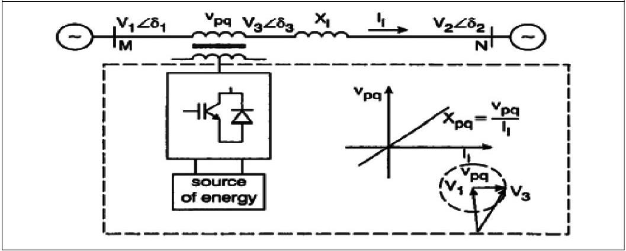
Fig 3.1 Block diagram for SSSC
The development of FACTS-devices has started with the growing capabilities of power electronic components. Devices for high power levels have been made available in converters for high and even highest voltage levels. The overall starting points are network elements influencing the reactive power or the impedance of a part of the power system. Figure shows a number of basic devices separated into the conventional ones and the FACTS-devices.
For the FACTS side the taxonomy in terms of 'dynamic' and 'static' needs some explanation. The term 'dynamic' is used to express the fast controllability of FACTS-devices provided by the power electronics. This is one of the main differentiation factors from the conventional devices.
The term 'static' means that the devices have no moving parts like mechanical switches to perform the dynamic controllability. Therefore most of the FACTS-devices can equally be static and dynamic.
The block diagram for SSSC as in figure 3.1.The compensator is equipped with a source of energy, which helps in supplying or absorbing active power to or from the transmission line with the control of reactive power flow.
The overall starting points are network elements influencing the reactive power or the impedance of a part of the power system. Figure shows a number of basic devices separated into the conventional ones and the FACTS-devices

4.BASIC DESCRIPTION OF FACTS DEVICES
4.1 Static Synchronous Compensator (Statcom)
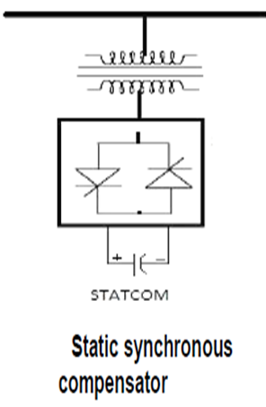
Fig 4.1 Static Synchronous Compensator
The static synchronous compensator (STATCOM) is another shunt connected GTO based FACTS device. STATCOM is a static synchronous generator operated as a static VAR compensator which can inject lagging or leading var into the system. STATCOM have several advantages. It has no rotating parts, very fast in response, requires less space as bulky passive components are eliminated, inherently modular and relocatable, less maintenance and no problem as loss of synchronism.Simple diagram of STATCOM is shown in figure .The dc source voltage is converted into ac voltage by the voltage source converter using GTO and ac voltage is inserted into the line through the transformer. In heavy loaded condition if. Output of VSC is more than the line voltage, converter supplies lagging VARs to the transmission line. During low load condition if line voltage is more than then converter absorbs lagging VAR from the system. If o/p voltage of converter is equal to line voltage, then the STATCOM is in floating condition and this shunt device does not supply or absorb reactive power to the system or from the system.
The term 'static' means that the devices have no moving parts like mechanical switches to perform the dynamic controllability. Therefore most of the FACTS-devices can equally be static and dynamic.
4.2 Thyristor Controlled Series Capacitor (Tcsc)
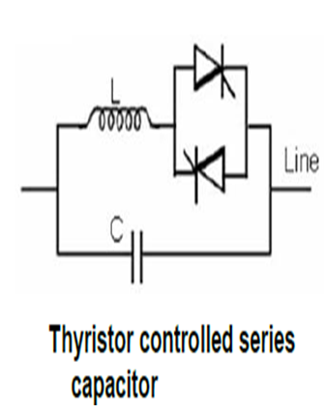
Fig 4.2 Thyristor controlled series capacitor
Thyristor controlled series capacitor (TCSC) is very important series compensator like SSSC. Especially in this FACTS (Flexible alternating transmission system) device, thyristor with gate turn-off capability is not required.The above figure shows schematic diagram of a TCSC controller. In TCSC, capacitor is inserted directly into the transmission line and TCR are mounted in parallel with the capacitor. As the capacitor is inserted in series with the line, there is no need of using high voltage transformer and thus it gives better economy. Firing angle of back to back thyristors are controlled to control the reactor. At 180° firing angle TCR, is non- conducting and at 90° firing angle TCR is in full conduction.
Advantages
- Continuous control of desired compensation level.
- Direct smooth control of power flow within the network.

4.3 Static Synchronous Series Compensator (Sssc)
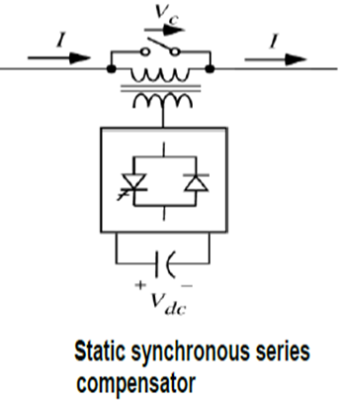
fig 4.3 Static synchronous series compensator
In present days, SSSC is one of the most important FACTS controller used for series compensation of power. In series compensation the capacitor which is connected in series compensates the inductive reactance of the transmission line. SSSC output voltage (Vc) is in quadrature with the line current (I). The voltage across series capacitor is –jXcI (where Xc is the capacitive reactance of the series capacitor) and voltage drop across line inductance (XL) is +jXLI cancel each other thus reducing the effect of line inductance. Due to this, power transfer capability is increased .The symbolic representation of SSSC using voltage source converter is shown in figure. Supply voltage from a dc source is converted into ac voltage using VSC (voltage source converter). Quadrature voltage is injected into the line through a coupling transformer. This injected voltage (Vc) lags the line current (I) by 90ºand series compensation is done. SSSC control flow of real and reactive power through the system.
Electrical loads both generate and absorb reactive power. Since the transmitted load varies considerably from one hour to another, the reactive power balance in a grid varies as well. The result can be unacceptable voltage amplitude variations or even a voltage depression, at the extreme a voltage collapse.
4.4 Unified Power Flow Controller (Upfc)
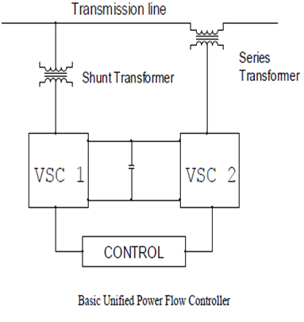
Fig 4.4 Unified power flow controller
Figure shows a schematic diagram of UPFC. Full form of UPFC is Unified power flow controller. The word unified signifies all parameters (e.g.- voltage, phase angle, impedance, real and reactive power and power factor) which effect power flow in the system can be controlled. UPFC is the most modernised device among all the FACTS devices which can be used to enhance steady-state stability, dynamic stability, real and reactive power flow and so on. UPFC consists of two converters. One converter (SSSC) is connected in series with the transmission line and other converter (STATCOM) is connected in parallel with the transmission line. The two converters are coupled through a common dc link which provides bidirectional flow of real power between series o/p SSSC and shunt output STATCOM respectively. For balancing of power between series and shunt controller it is necessary to maintain constant voltage across the dc link. Series branch (SSSC) of the UPFC injects variable magnitude voltage and phase angle. This improves power flow capability and transient stability.
Operating Principle Of Upfc
The basic components of the UPFC are two voltage source inverters (VSIs) sharing a common dc storage capacitor, and connected to the power system through coupling transformers. One VSI is connected to in shunt to the transmission system via a shunt transformer, while the other one is connected in series through a series transformer.
Fig4.5 Operating principle of upfc
The series inverter is controlled to inject a symmetrical three phase voltage system (VSC), of controllable magnitude and phase angle in series with the line to control active and reactive power flows on the transmission line. So, this inverter will exchange active and reactive power with the line. The reactive power is electronically provided by the series inverter, and the active power is transmitted to the dc terminals. The shunt inverter is operated in such a way as to demand this dc terminal power (positive or negative) from the line keeping the voltage across the storage capacitor Vdc constant. So, the net real power absorbed from the line by the UPFC is equal only to the losses of the inverters and their transformers. The remaining capacity of the shunt inverter can be used to exchange reactive power with the line so to provide a voltage regulation at the connection point.
The two VSI’s can work independently of each other by separating the dc side. So in that case, the shunt inverter is operating as a STATCOM that generates or absorbs reactive power to regulate the voltage magnitude at the connection point. Instead, the series inverter is operating as SSSC that generates or absorbs reactive power to regulate the current flow, and hence the power low on the transmission line.
The UPFC has many possible operating modes. In particular, the shunt inverter is operating in such a way to inject a controllable current, ish into the transmission line. The shunt inverter can be controlled in two different modes:
VAR Control Mode: The reference input is an inductive or capacitive VAR request. The shunt inverter control translates the var reference into a corresponding shunt current request and adjusts gating of the inverter to establish the desired current. For this mode of control a feedback signal representing the dc bus voltage, Vdc, is also required.
Automatic Voltage Control Mode: The shunt inverter reactive current is automatically regulated to maintain the transmission line voltage at the point of connection to a reference value. For this mode of control, voltage feedback signals are obtained from the sending end bus feeding the shunt coupling transformer.
The series inverter controls the magnitude and angle of the voltage injected in series with the line to influence the power flow on the line. The actual value of the injected voltage can be obtained in several ways.
Direct Voltage Injection Mode: The reference inputs are directly the magnitude and phase angle of the series voltage. Phase Angle Shifter Emulation mode: The reference input is phase displacement between the sending end voltage and the receiving end voltage.

5. INTRODUCTION TO POWER ELECTRONICS
Power Electronics is a field which combines Power (electric power), Electronics and Control systems. Power engineering deals with the static and rotating power equipment for the generation, transmission and distribution of electric power. Electronics deals with the study of solid state semiconductor power devices and circuits for Power conversion to meet the desired control objectives (to control the output voltage and output power).
Power electronics may be defined as the subject of applications of solid state power semiconductor devices (Thyristors) for the control and conversion of electric power.
Power electronics deals with the study and design of Thyristorised power controllers for variety of application like Heat control, Light/Illumination control, Motor control – AC/DC motor drives used in industries, High voltage power supplies, Vehicle propulsion systems, High voltage direct current (HVDC) transmission.
5.1 Power Electronic Applications
Commercial Applications
Heating Systems Ventilating, Air Conditioners, Central Refrigeration, Lighting, Computers and Office equipments, Uninterruptible Power Supplies (UPS), Elevators, and Emergency Lamps.
Domestic Applications
Cooking Equipments, Lighting, Heating, Air Conditioners, Refrigerators & Freezers, Personal Computers, Entertainment Equipments, UPS.
Industrial Applications
Pumps, compressors, blowers and fans. Machine tools, arc furnaces, induction furnaces, lighting control circuits, industrial lasers, induction heating, welding equipments.
Aerospace Applications
Space shuttle power supply systems, satellite power systems, aircraft power systems.
Telecommunications
Battery chargers, power supplies (DC and UPS), mobile cell phone battery chargers.
Transportation
Traction control of electric vehicles, battery chargers for electric vehicles, electric locomotives, street cars, trolley buses, automobile electronics including engine controls.
Utility Systems
High voltage DC transmission (HVDC), static VAR compensation (SVC), Alternative energy sources (wind, photovoltaic), fuel cells, energy storage systems, induced draft fans and boiler feed water pumps.
5.2 Differences Between Electronics And Power Electronics
This question can be answered in number of ways. the simplest way to say all the electronics devices which deals with power are covered in power electronics. There are devices which you do use in general purpose electronics like: Diode, BJT, MFETs etc. You will find these devices in electronics & power electronics both. The devices used in Power electronics may differ in term of construction & behavior from those used in electronics. There are type of devices which you will find only IN PE, ex: IGBT.
- The only difference is that power devices (e.g. MOSFETs) are made to handle much larger power requirements.
- Ordinary devices are low current and low voltage devices.
- Power devices are high current and/or high voltage devices.
5.3 Power Converters
A power converter is an electrical or electro-mechanical device for converting electrical energy. It may be converting AC to or from DC, or the voltage or frequency, or some combination of these.
Amongst the many devices that are used for this purpose are;
- Rectifier
- Inverter
- DC - DC converter
- AC - AC converter
Ac - Dc Converter (Rectifier)
A rectifier is an electrical device that converts alternating current (AC), which periodically reverses direction, to direct current (DC), which is in only one direction, a process known as rectification.
Rectifiers have many uses including as components of power supplies and as detectors of radio signals. Rectifiers may be made of solid state diodes, vacuum tube diodes, mercury arc valves, and other components.
Dc - Ac Converter (Inverter)
An inverter is an electrical device that converts direct current (DC) to alternating current (AC); the converted AC can be at any required voltage and frequency with the use of appropriate transformers, switching, and control circuits.
Solid-state inverters have no moving parts and are used in a wide range of applications, from small switching power supplies in computers, to large electric utility high-voltage direct current applications that transport bulk power. Inverters are commonly used to supply AC power from DC sources such as solar panels or batteries.
Dc - Dc Converter (Choppers)
A dc chopper is a dc-to-dc voltage converter. It is a static switching electrical appliance that in one Electrical conversion, changes an input fixed dc voltage to an adjustable dc output voltage without Inductive or capacitive intermediate energy storage. The name chopper is connected with the fact that the output voltage is a ‘chopped up’ quasi-rectangular version of the input dc voltage.
Ac - Ac Converter
An AC/AC converter converts an AC waveform such as the mains supply, to another AC waveform, where the output voltage and frequency can be set arbitrarily.
AC/AC converters can be categorized into
- Cycloconverters
- Matrix Converters
5.4 Power Electronic Switches
In electronics, a switch is an electrical component that can break an electrical circuit, interrupting the current or diverting it from one conductor to another.
A power electronic switch integrates a combination of power electronic components or power semiconductors and a driver for the actively switchable power semiconductors. The internal functional correlations and interactions of this integrated system determine several
Diodes
In electronics, a diode is a type of two-terminal electronic component with a nonlinear current–voltage characteristic. A semiconductor diode, the most common type today, is a crystalline piece of semiconductor material connected to two electrical terminals. A vacuum tube diode (now rarely used except in some high-power technologies) is a vacuum tube with two electrodes: a plate and a cathode.
The most common function of a diode is to allow an electric current to pass in one direction (called the diode's forward direction), while blocking current in the opposite direction (the reverse direction). Thus, the diode can be thought of as an electronic version of a check valve. This unidirectional behavior is called rectification, and is used to convert alternating current to direct current, and to extract modulation from radio signals in radio receivers.
However, diodes can have more complicated behavior than this simple on–off action. Semiconductor diodes do not begin conducting electricity until a certain threshold voltage is present in the forward direction (a state in which the diode is said to be forward biased).
The voltage drop across a forward biased diode varies only a little with the current, and is a function of temperature; this effect can be used as a temperature sensor or voltage reference.
Semiconductor diodes have nonlinear electrical characteristics, which can be tailored by varying the construction of their P–N junction. These are exploited in special purpose diodes that perform many different functions.
Diodes were the first semiconductor electronic devices. The discovery of crystals' rectifying abilities was made by German physicist Ferdinand Braun in 1874. The first semiconductor diodes, called cat's whisker diodes, developed around 1906, were made of mineral crystals such as galena. Today most diodes are made of silicon, but other semiconductors such as germanium are sometimes used.
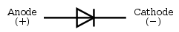
A modern semiconductor diode is made of a crystal of semiconductor like silicon that has impurities added to it to create a region on one side that contains negative charge carriers (electrons), called n-type semiconductor, and a region on the other side that contains positive charge carriers (holes), called p-type semiconductor. The diode's terminals are attached to each of these regions. The boundary within the crystal between these two regions, called a PN junction, is where the action of the diode takes place. The crystal conducts a current of electrons in a direction from the N-type side (called the cathode) to the P-type side (called the anode), but not in the opposite direction. However, conventional current flows from anode to cathode in the direction of the arrow (opposite to the electron flow, since electrons have negative charge).
Another type of semiconductor diode, the Scotty diode, is formed from the contact between a metal and a semiconductor rather than by a p–n junction.
Thyristors
A thyristor is a solid-state semiconductor device with four layers of alternating n and p-type material. They act as bistable switches, conducting when their gate receives a current pulse, and continue to conduct while they are forward biased (that is, while the voltage across the device is not reversed).
Some sources define silicon controlled rectifiers and thyristors as synonymous.
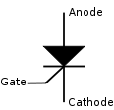
Fig 5.1 Circuit symbol for thyristor
Function
The thyristor is a four-layer, three terminal semiconducting device, with each layer consisting of alternately N-type or P-type material, for example P-N-P-N. The main terminals, labeled anode and cathode, are across the full four layers, and the control terminal, called the gate, is attached to p-type material near to the cathode. (A variant called an SCS—Silicon Controlled Switch—brings all four layers out to terminals.) The operation of a thyristor can be understood in terms of a pair of tightly coupled bipolar junction transistors, arranged to cause the self-latching action:
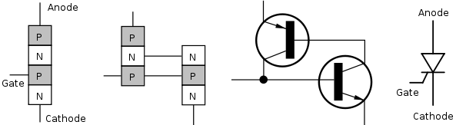
fig 5.2 Structure on the physical and electronic level, and the thyristor symbol.
Thyristors have three states
- Reverse blocking mode — Voltage is applied in the direction that would be blocked by a diode
- Forward blocking mode — Voltage is applied in the direction that would cause a diode to conduct, but the thyristor has not yet been triggered into conduction
- Forward conducting mode — The thyristor has been triggered into conduction and will remain conducting until the forward current drops below a threshold value known as the "holding current"

Insulated Gate Bipolar Transistor (Igbt)
The insulated-gate bipolar transistor or IGBT is a three-terminal power semiconductor device, noted for high efficiency and fast switching. It switches electric power in many modern appliances: electric cars, variable speed refrigerators, air-conditioners, and even stereo systems with digital amplifiers. Since it is designed to rapidly turn on and off, amplifiers that use it often synthesize complex waveforms with pulse width modulation and low-pass filters.
The IGBT combines the simple gate-drive characteristics of the MOSFETs with the high-current and low–saturation-voltage capability of bipolar transistors by combining an isolated-gate FET for the control input, and a bipolar power transistor as a switch, in a single device. The IGBT is used in medium- to high-power applications such as switched-mode power supply, traction motor control and induction heating. Large IGBT modules typically consist of many devices in parallel and can have very high current handling capabilities in the order of hundreds of amps with blocking voltages of 6,000 V
Equivalent Circuit
An examination of reveals that if we move vertically up from collector to emitter. We come across p+, n- , p layer s. Thus, IGBT can be thought of as the combination of MOSFET and p+ n⁻ p layer s. Thus, IGBT can be thought of as the combination of MOSFET and p⁺ n⁻ p transistor Q1 .
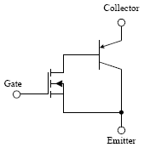
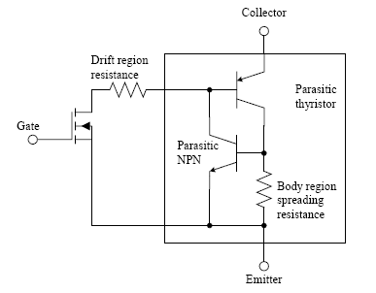
Mosfet
The metal–oxide–semiconductor field-effect transistor (MOSFET, MOS-FET, or MOS FET) is a transistor used for amplifying or switching electronic signals. The basic principle of this kind of transistor was first proposed by Julius Edgar Lilienfeld in 1925. In MOSFETs, a voltage on the oxide-insulated gate electrode can induce a conducting channel between the two other contacts called source and drain. The channel can be of n-type or p-type (see article on semiconductor devices), and is accordingly called an nMOSFET or a pMOSFET (also commonly nMOS, pMOS). It is by far the most common transistor in both digital and analog circuits, though the bipolar junction transistor was at one time much more common. The insulated-gate bipolar transistor or IGBT is a three-terminal power semiconductor device, noted for high efficiency and fast switching. It switches electric power in many modern appliances: electric cars, variable speed refrigerators, air-conditioners, and even stereo systems with digital amplifiers. Since it is designed to rapidly turn on and off, amplifiers that use it often synthesize complex waveforms with pulse width modulation and low-pass filters.
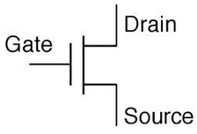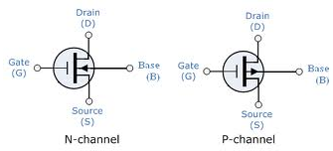
Fig 5.3 Circuit diagram for MOSFET
The 'metal' in the name is now often a misnomer because the previously metal gate material is now often a layer of polysilicon (polycrystalline silicon). Aluminium had been the gate material until the mid 1970s, when polysilicon became dominant, due to its capability to form self-aligned gates. Metallic gates are regaining popularity, since it is difficult to increase the speed of operation of transistors without metal gates.
Mosfet Operation
A metal–oxide–semiconductor field-effect transistor (MOSFET) is based on the modulation of charge concentration by a MOS capacitance between a body electrode and a gate electrode located above the body and insulated from all other device regions by a gate dielectric layer which in the case of a MOSFET is an oxide, such as silicon dioxide. If dielectrics other than an oxide such as silicon dioxide (often referred to as oxide) are employed the device may be referred to as a metal–insulator–semiconductor FET (MISFET). Compared to the MOS capacitor, the MOSFET includes two additional terminals (source and drain), each connected to individual highly doped regions that are separated by the body region. These regions can be either p or n type, but they must both be of the same type, and of opposite type to the body region. The source and drain (unlike the body) are highly doped as signified by a '+' sign after the type of doping.
If the MOSFET is an n-channel or nMOSFET, then the source and drain are 'n+' regions and the body is a 'p' region. As described above, with sufficient gate voltage, holes from the body are driven away from the gate, forming an inversion layer or n-channel at the interface between the p region and the oxide. This conducting channel extends between the source and the drain, and current is conducted through it when a voltage is applied between source and drain. Increasing the voltage on the gate leads to a higher electron density in the inversion layer and therefore increases the current flow between the source and drain.
For gate voltages below the threshold value, the channel is lightly populated, and only a very small sub threshold leakage current can flow between the source and the drain.
If the MOSFET is a p-channel or pMOSFET, then the source and drain are 'p+' regions and the body is a 'n' region. When a negative gate-source voltage (positive source-gate) is applied, it creates a p-channel at the surface of the n region, analogous to the n-channel case, but with opposite polarities of charges and voltages.
When a voltage less negative than the threshold value (a negative voltage for p-channel) is applied between gate and source, the channel disappears and only a very small sub threshold current can flow between the source and the drain.
The source is so named because it is the source of the charge carriers (electrons for n-channel, holes for p-channel) that flow through the channel; similarly, the drain is where the charge carriers leave the channel.
The device may comprise a Silicon On Insulator (SOI) device in which a Buried OXide (BOX) is formed below a thin semiconductor layer. If the channel region between the gate dielectric and a Buried Oxide (BOX) region is very thin, the very thin channel region is referred to as an Ultra Thin Channel (UTC) region with the source and drain regions formed on either side thereof in and/or above the thin semiconductor layer. Alternatively, the device may comprise a Semiconductor On Insulator (SEMOI) device in which semiconductors other than silicon are employed. Many alternative semiconductor materials may be employed.
5.5 Multi Level Converter
An inverter is an electrical device that converts direct current (DC) to alternating current (AC); the converted AC can be at any required voltage and frequency with the use of appropriate transformers, switching, and control circuits.
Static inverters have no moving parts and are used in a wide range of applications, from small switching power supplies in computers, to large electric utility high-voltage direct current applications that transport bulk power. Inverters are commonly used to supply AC power from DC sources such as solar panels or batteries.
The electrical inverter is a high-power electronic oscillator. It is so named because early mechanical AC to DC converters was made to work in reverse, and thus were "inverted", to convert DC to AC.
Cascaded H-Bridges Inverter
A single-phase structure of an m-level cascaded inverter is illustrated in Figure 5.3. Each separate dc source (SDCS) is connected to a single-phase full-bridge, or H-bridge, inverter. Each inverter level can generate three different voltage outputs, +V_{dc}, 0, and –V_{dc} by connecting the dc source to the ac output by different combinations of the four switches, S₁, S₂, S₃, and S₄. To obtain +V_{dc}, switches S₁ and S₄ are turned on, whereas –V_{dc} can be obtained by turning on switches S₂ and S₃. By turning on S₁ and S₂ or S₃ and S₄, the output voltage is 0. The ac outputs of each of the different full-bridge inverter levels are connected in series such that the synthesized voltage waveform is the sum of the inverter outputs. The number of output phase voltage levels m in a cascade inverter is defined by m = 2s+1, where s is the number of separate dc sources. An example phase voltage waveform for an 11-level cascaded H-bridge inverter with 5 SDCSs and 5 full bridges is shown in Figure 31.2. The phase voltage v_{an} = v_{a1} + v_{a2} + v_{a3} + v_{a4} + v_{a5}. The Fourier Transform for this waveform follows
Fig 5.4 Single-phase structure of a multilevel cascaded H-bridges inverter
Fig 5.5 Output phase voltage waveform of an 11-level cascade inverter with 5 separate dc sources
The magnitudes of the Fourier coefficients when normalized with respect to V_{dc} are as follows:
The conducting angles, θ₁, θ₂, ..., θ_{s}, can be chosen such that the voltage total harmonic distortion is a minimum. Generally, these angles are chosen so that predominant lower frequency harmonics, 5th, 7th, 11th, and 13th, harmonics are eliminated. More detail on harmonic elimination techniques will be presented in the next section.
Multilevel cascaded inverters have been proposed for such applications as static var generation, an interface with renewable energy sources, and for battery-based applications. Three-phase cascaded inverters can be connected in wye, as shown in Figure, or in delta. Peng has demonstrated a prototype multilevel cascaded static var generator connected in parallel with the electrical system that could supply or draw reactive current from an electrical system.
The inverter could be controlled to either regulate the power factor of the current drawn from the source or the bus voltage of the electrical system where the inverter was connected. Peng [20] and Joos [24] have also shown that a cascade inverter can be directly connected in series with the electrical system for static var compensation. Cascaded inverters are ideal for connecting renewable energy sources with an ac grid, because of the need for separate dc sources, which is the case in applications such as photovoltaic’s or fuel cells.
Cascaded inverters have also been proposed for use as the main traction drive in electric vehicles, where several batteries or ultra capacitors are well suited to serve as SDCSs. The cascaded inverter could also serve as a rectifier/charger for the batteries of an electric vehicle while the vehicle was connected to an ac supply as shown in Figure. Additionally, the cascade inverter can act as a rectifier in a vehicle that uses regenerative braking.
Generally, these angles are chosen so that predominant lower frequency harmonics, 5th, 7th, 11th, and 13th, harmonics are eliminated. More detail on harmonic elimination techniques will be presented in the next section.

Fig 5.6 Three-phase wye-connection structure for electric vehicle motor drive and battery charging.
The main advantages and disadvantages of multilevel cascaded H-bridge converters are as follows
Advantages
- The number of possible output voltage levels is more than twice the number of dc sources (m = 2s + 1).
- The series of H-bridges makes for modularized layout and packaging. This will enable the manufacturing process to be done more quickly and cheaply.
Disadvantages
- Separate dc sources are required for each of the H-bridges. This will limit its application to products that already have multiple SDCSs readily available.

Diode-Clamped Multilevel Inverter
The neutral point converter proposed by Nabae, Takahashi, and Akagi in 1981 was essentially a three-level diode-clamped inverter. In the 1990s several researchers published articles that have reported experimental results for four-, five-, and six-level diode-clamped converters for such uses as static VAR compensation, variable speed motor drives, and high-voltage system interconnections.
A three-phase six-level diode-clamped inverter is shown in Figure. Each of the three phases of the inverter shares a common dc bus, which has been subdivided by five capacitors into six levels. The voltage across each capacitor is V_{dc}, and the voltage stress across each switching device is limited to V_{dc} through the clamping diodes. Table lists the output voltage levels possible for one phase of the inverter with the negative dc rail voltage V₀ as a reference. State condition 1 means the switch is on, and 0 means the switch is off. Each phase has five complementary switch pairs such that turning on one of the switches of the pair requires that the other complementary switch be turned off. The complementary switch pairs for phase leg a are (S_{a1}, S_{a’1}), (S_{a2}, S_{a’2}), (S_{a3}, S_{a’3}), (S_{a4}, S_{a’4}), and (S_{a5}, S_{a’5}). Table also shows that in a diode-clamped inverter, the switches that are on for a particular phase leg are always adjacent and in series. For a six-level inverter, a set of five switches is on at any given time.
Fig 5.7 Three-phase six-level structure of a diode-clamped inverter.
Table 5.1 Diode-clamped six-level inverter voltage levels and corresponding switch states.
Table lists the output voltage levels possible for one phase of the inverter with the negative dc rail voltage V₀ as a reference. State condition 1 means the switch is on, and 0 means the switch is off.
Advantages
- All of the phases share a common dc bus, which minimizes the capacitance requirements of the converter. For this reason, a back-to-back topology is not only possible but also practical for uses such as a high-voltage back-to-back inter-connection or an adjustable speed drive.
- Efficiency is high for fundamental frequency switching.
Disadvantages
- The capacitors can be pre-charged as a group.
- Real power flow is difficult for a single inverter because the intermediate dc levels will tend to overcharge or discharge without precise monitoring and control.
- The number of clamping diodes required is quadratic ally related to the number of levels, which can be cumbersome for units with a high number of levels.
Flying Capacitor Multilevel Inverter
Fig 5.8 Three-phase six-level structure of a flying capacitor inverter.
Meynard and Foch introduced a flying-capacitor-based inverter in 1992 . The structure of this inverter is similar to that of the diode-clamped inverter except that instead of using clamping diodes, the inverter uses capacitors in their place. The circuit topology of the flying capacitor multilevel inverter is shown in Figure This topology has a ladder structure of dc side capacitors, where the voltage on each capacitor differs from that of the next capacitor. The voltage increment between two adjacent capacitor legs gives the size of the voltage steps in the output waveform.
One advantage of the flying-capacitor-based inverter is that it has redundancies for inner voltage levels; in other words, two or more valid switch combinations can synthesize an output voltage. Table shows a list of all the combinations of phase voltage levels that are possible for the six-level circuit shown in Figure . Unlike the diode-clamped inverter, the flying-capacitor inverter does not require all of the switches that are on (conducting) be in a consecutive series.
Moreover, the flying-capacitor inverter has phase redundancies, whereas the diode-clamped inverter has only line-line redundancies. These redundancies allow a choice of charging/discharging specific capacitors and can be incorporated in the control system for balancing the voltages across the various levels.
In addition to the (m-1) dc link capacitors, the m-level flying-capacitor multilevel inverter will require (m-1) × (m-2)/2 auxiliary capacitors per phase if the voltage rating of the capacitors is identical to that of the main switches. One application proposed in the literature for the multilevel flying capacitor is static VAR generation. The main advantages and disadvantages of multilevel flying capacitor converters are as follows.
Advantages
- Phase redundancies are available for balancing the voltage levels of the capacitors.
- Real and reactive power flow can be controlled.
- The large number of capacitors enables the inverter to ride through short duration outages and deep voltage sags.

6. INTRODUCTION TO PWM
6.1 Pulse Width Modulation (Pwm)
Pulse Width Modulation (PWM) is the most effective means to achieve constant voltage battery charging by switching the solar system controller’s power devices. When in PWM regulation, the current from the solar array tapers according to the battery’s condition and recharging needs Consider a waveform such as this: it is a voltage switching between 0v and 12v. It is fairly obvious that, since the voltage is at 12v for exactly as long as it is at 0v, then a 'suitable device' connected to its output will see the average voltage and think it is being fed 6v - exactly half of 12v. So by varying the width of the positive pulse - we can vary the 'average' voltage.
Similarly, if the switches keep the voltage at 12 for 3 times as long as at 0v, the average will be 3/4 of 12v - or 9v, as shown below and if the output pulse of 12v lasts only 25% of the overall time, then the average is
By varying - or 'modulating' - the time that the output is at 12v (i.e. the width of the positive pulse) we can alter the average voltage. So we are doing 'pulse width modulation'. I said earlier that the output had to feed 'a suitable device'. A radio would not work from this: the radio would see 12v then 0v, and would probably not work properly. However a device such as a motor will respond to the average, so PWM is a natural for motor control.
6.2 Pulse Width Modulator
So, how do we generate a PWM waveform? It's actually very easy, there are circuits available in the TEC site. First you generate a triangle waveform as shown in the diagram below. You compare this with a d.c voltage, which you adjust to control the ratio of on to off time that you require. When the triangle is above the 'demand' voltage, the output goes high. When the triangle is below the demand voltage, the
When the demand speed it in the middle (A) you get a 50:50 output, as in black. Half the time the output is high and half the time it is low. Fortunately, there is an IC (Integrated circuit) called a comparator: these come usually 4 sections in a single package. One can be used as the oscillator to produce the triangular waveform and another to do the comparing, so a complete oscillator and modulator can be done with half an IC and maybe 7 other bits.
The triangle waveform, which has approximately equal rise and fall slopes, is one of the commonest used, but you can use a saw tooth (where the voltage falls quickly and rinses slowly). You could use other waveforms and the exact linearity (how good the rise and fall are) is not too important.
Traditional solenoid driver electronics rely on linear control, which is the application of a constant voltage across a resistance to produce an output current that is directly proportional to the voltage. Feedback can be used to achieve an output that matches exactly the control signal. However, this scheme dissipates a lot of power as heat, and it is therefore very inefficient.
A more efficient technique employs pulse width modulation (PWM) to produce the constant current through the coil. A PWM signal is not constant. Rather, the signal is on for part of its period, and off for the rest. The duty cycle, D, refers to the percentage of the period for which the signal is on. The duty cycle can be anywhere from 0, the signal is always off, to 1, where the signal is constantly on. A 50% D results in a perfect square wave. (Figure 1)
A solenoid is a length of wire wound in a coil. Because of this configuration, the solenoid has, in addition to its resistance, R, a certain inductance, L. When a voltage, V, is applied across an inductive element, the current, I, produced in that element does not jump up to its constant value, but gradually rises to its maximum over a period of time called the rise time (above fig). Conversely, I does not disappear instantaneously, even if V is removed abruptly, but decreases back to zero in the same amount of time as the rise time.
Therefore, when a low frequency PWM voltage is applied across a solenoid, the current through it will be increasing and decreasing as V turns on and off. If D is shorter than the rise time, I will never achieve its maximum value, and will be discontinuous since it will go back to zero during V’s off period (above fig).
At high frequencies, V turns on and off very quickly, regardless of D, such that the current does not have time to decrease very far before the voltage is turned back on. The resulting current through the solenoid is therefore considered to be constant. By adjusting the D, the amount of output current can be controlled. With a small D, the current will not have much time to rise before the high frequency PWM voltage takes effect and the current stays constant. With a large D, the current will be able to rise higher before it becomes constant.
6.3 Why The Pwm Frequency Is Important
The PWM is a large amplitude digital signal that swings from one voltage extreme to the other. And, this wide voltage swing takes a lot of filtering to smooth out. When the PWM frequency is close to the frequency of the waveform that you are generating, then any PWM filter will also smooth out your generated waveform and drastically reduce its amplitude. So, a good rule of thumb is to keep the PWM frequency much higher than the frequency of any waveform you generate.
Finally, filtering pulses is not just about the pulse frequency but about the duty cycle and how much energy is in the pulse. The same filter will do better on a low or high duty cycle pulse compared to a 50% duty cycle pulse. Because the wider pulse has more time to integrate to a stable filter voltage and the smaller pulse has less time to disturb it the inspiration was a request to control the speed of a large positive displacement fuel pump. The pump was sized to allow full power of a boosted engine in excess of 600 Hp.
At idle or highway cruise, this same engine needs far less fuel yet the pump still normally supplies the same amount of fuel. As a result the fuel gets recycled back to the fuel tank, unnecessarily heating the fuel. This PWM controller circuit is intended to run the pump at a low speed setting during low power and allow full pump speed when needed at high engine power levels.
6.4 Pwm Controller Features
This controller offers a basic “Hi Speed” and “Low Speed” setting and has the option to use a “Progressive” increase between Low and Hi speed. Low Speed is set with a trim pot inside the controller box. Normally when installing the controller, this speed will be set depending on the minimum speed/load needed for the motor. Normally the controller keeps the motor at this Lo Speed except when Progressive is used and when Hi Speed is commanded (see below). Low Speed can vary anywhere from 0% PWM to 100%.
Progressive control is commanded by a 0-5 volt input signal. This starts to increase PWM% from the low speed setting as the 0-5 volt signal climbs. This signal can be generated from a throttle position sensor, a Mass Air Flow sensor, a Manifold Absolute Pressure sensor or any other way the user wants to create a 0-5 volt signal. This function could be set to increase fuel pump power as turbo boost starts to climb (MAP sensor). Or, if controlling a water injection pump, Low Speed could be set at zero PWM% and as the TPS signal climbs it could increase PWM%, effectively increasing water flow to the engine as engine load increases.
This controller could even be used as a secondary injector driver (several injectors could be driven in a batch mode, hi impedance only), with Progressive control (0-100%) you could control their output for fuel or water with the 0-5 volt signal.
Progressive control adds enormous flexibility to the use of this controller. Hi Speed is that same as hard wiring the motor to a steady 12 volt DC source. The controller is providing 100% PWM, steady 12 volt DC power. Hi Speed is selected three different ways on this controller: 1) Hi Speed is automatically selected for about one second when power goes on. This gives the motor full torque at the start. If needed this time can be increased ( the value of C1 would need to be increased). 2) High Speed can also be selected by applying 12 volts to the High Speed signal wire. This gives Hi Speed regardless of the Progressive signal.
6.5 Sinusoidal Pulse Width Modulation
In many industrial applications, Sinusoidal Pulse Width Modulation (SPWM), also called Sine coded Pulse Width Modulation, is used to control the inverter output voltage. SPWM maintains good performance of the drive in the entire range of operation between zero and 78 percent of the value that would be reached by square-wave operation. If the modulation index exceeds this value, linear relationship between modulation index and output voltage is not maintained and the over-modulation methods are required.
Comparison
In Fig comparison, U is the phase to- center voltage containing the triple order harmonics that are generated by space vector PWM, and U1 is the sinusoidal reference voltage. But the triple order harmonics are not appeared in the phase-to-phase voltage as well. This leads to the higher modulation index compared to the SPWM.
Comparison Of Spwm And Space Vector Pwm
As mentioned above, SPWM only reaches to 78 percent of square wave operation, but the amplitude of maximum possible voltage is 90 percent of square-wave in the case of space vector PWM. The maximum phase-to-center voltage by sinusoidal and space vector PWM are respectively
Vmax = Vdc/2 : Sinusoidal PWM
Vmax = Vdc/√3 : Space Vector PWM
Where, Vdc is DC-Link voltage.
This means that Space Vector PWM can produce about 15 percent higher than Sinusoidal PWM in output voltage.
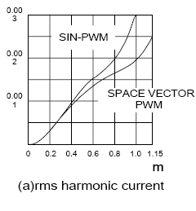
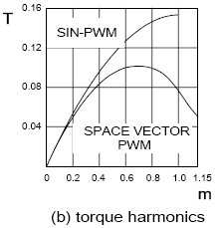
6.6 Svm Pwm Technique
The Pulse Width modulation technique permits to obtain three phase system voltages, which can be applied to the controlled output. Space Vector Modulation (SVM) principle differs from other PWM processes in the fact that all three drive signals for the inverter will be created simultaneously. The implementation of SVM process in digital systems necessitates less operation time and also less program memory.
The SVM algorithm is based on the principle of the space vector u*, which describes all three output voltages ua, ub and uc :
u* = 2/3 . ( ua + a . ub + a2 . uc ) ………(1)
Where a = -1/2 + j . v3/2 We can distinguish six sectors limited by eight discrete vectors u0…u7 (fig:- inverter output voltage space vector), which correspond to the 23 = 8 possible switching states of the power switches of the inverter.
Fig 6.1 Space vector Modulation
The amplitude of u0 and u7 equals 0. The other vectors u1…u6 have the same amplitude and are 60 degrees shifted.
By varying the relative on-switching time Tc of the different vectors, the space vector u* and also the output voltages ua, ub and uc can be varied and is defined as:
ua = Re ( u* )
ub = Re ( u* . a-1)
uc = Re ( u* . a-2) …………(2)
Depending on the switching times t0, t1 and t2 the space vector u* is defined as:
u* = 1/Tc . ( t0 . u0 + t1 . u1 + t2 . u2 )
u* = t0 . u0 + t1 . u1 + t2 . u2
u* = t1 . u1 + t2 . u2 ………….. (3)
Where
t0 + t1 + t2 = Tc and
t0 + t1 + t2 = 1
t0, t1 and t2 are the relative values of the on switching times.
They are defined as: t1 = m. cos (a + p/6)
Their values are implemented in a table for a modulation factor m = 1. Then it will be easy to calculate the space vector u* and the output voltages ua, ub and uc. The voltage vector u* can be provided directly by the optimal vector control laws w1, v_{sa} and v_{sb}. In order to generate the phase voltages ua, ub and uc corresponding to the desired voltage vector u* the following SVM strategy is proposed.

6.7 Three-Level Inverter Analysis
A three-level inverter to ascertain the differences between it and a conventional two-level inverter For a three-phase three-level inverter, a structure similar to that used with 12 electronic devices (IGBT) is needed. Each phase will switch across three voltage levels (+V _{dc}/2, 0, and -V_{dc}/2). In a structure such as this the maximum voltage across the IGBT is limited to half the maximum dc link voltage (V_{dc}/2). This occurs because the IGBTs are connected to the neutral point (MP) by two fast diodes called neutral clamp diodes.
Three-phase two-level-inverter (PWM)-generation algorithms can also be applied to multilevel inverters. The algorithms with a triangular carrier waveform produce the best benefits in terms of harmonic distortion reduction, i.e. a three-level inverter needs both a carrier and a reference.
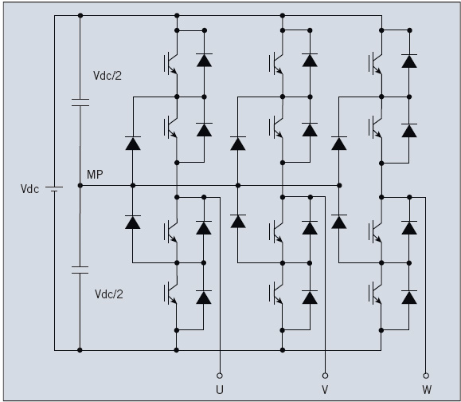
Fig .6.2 Three-phase three-level inverter topology, in which each phase switches across three voltage levels.
In this case the number of triangular carriers is equal to L-1, where L is the number of voltage levels. For a three-phase three-level inverter this means that two triangular carriers and one sinusoidal reference are needed.Three alternative PWM strategies with differing phase relationships can be used for a three-level inverter:
Alternative phase-opposition disposition (APOD), where carriers in adjacent bands are phase-shifted by 180°.

Three-Level Inverter Benefits
Phase-opposition dispositions (POD), where the carriers above the reference zero point are 180° out of phase with those below ze
PD strategy is used most frequently because it produces minimum harmonic distortion for the line-to-line output voltage. Triangular carriers and sinusoidal reference profiles, as well as IGBT and NCD current profiles, are shown in Fig,
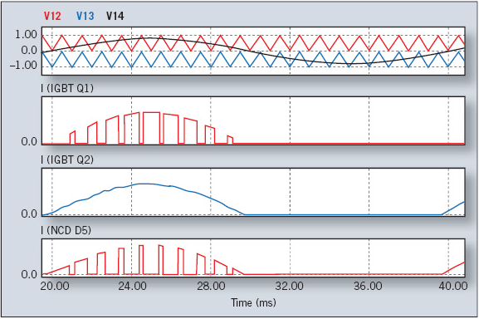
Fig. 6.3 Phase disposition (PD) three-level inverter
A three-level inverter features an IGBT with a lower reverse-blocking voltage: 600 V instead of 1,200 V. The 600-V chips are normally faster and thinner than 1,200-V chips. The silicon in a three-level inverter therefore has lower switching losses and a lower forward-voltage drop, the total losses per single arm of the three-level inverter are 60% lower than those of the two-level inverter. Q2 and Q3 switching losses are negligible. D1 and D4 diodes carry a very low current value since the current of Q1 commutes to D5; the current of Q4 commutes to D6, and the current of Q2 commutes to Q3. Clamp diodes carry the full load current.
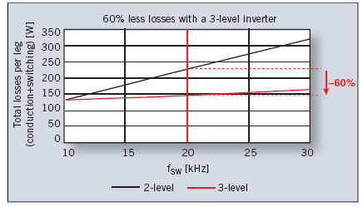
Fig.6.4 Overall losses as a function of the switching frequency for a single inverter leg (3L vs.2L )

7. SIMULATION RESULTS
At study on power oscillation damping, SSSC can be substituted by equivalent impedance, and the dynamic process is ignored. Fig is a common model of SSSC for system stability research: Stabilize controller strategy determines the order resistance X according to the input signal, and creates the resistance of SSSC through a delay component, whose time constant is decided by the main circuit characteristic. The common values of the time constant witch suitable trigger control strategy is 20~50 msec.
Fig.7.1 The model of SSSC
Because the impedance of the tie line of interconnected network is very large and the power flow through it often is very heavy. The power oscillation always performs as LFO between generators inside one district to those in another district. So we can analysis the control problem of SSSC in link line with an equivalent two machine system illustrated as Fig.
Here the generators adopt the classic two rank modes with temporary reactance behind temporary electric potential. For a system with nG generators and nL loads, its energy function can be defined as:
The components are kinetic energy and potential energy of generators, potential energy of loads, and potential energy relating to the reactive power of each branch, and the angle and rotate speed here are defined under the inertia center coordinate system
The reactance of SSSC can be replaced as the sum of stability value Xc0and controllable value Xcu, just as
The compensation degree can be defined. When Xcu changes during modulation, Kc always is negative and its change range is (Kcmin, Kcmax).
To simplify the discussion, the system in above fig is transformed into the equivalent model in Fig.
7.1 Two Machine System Without Sssc
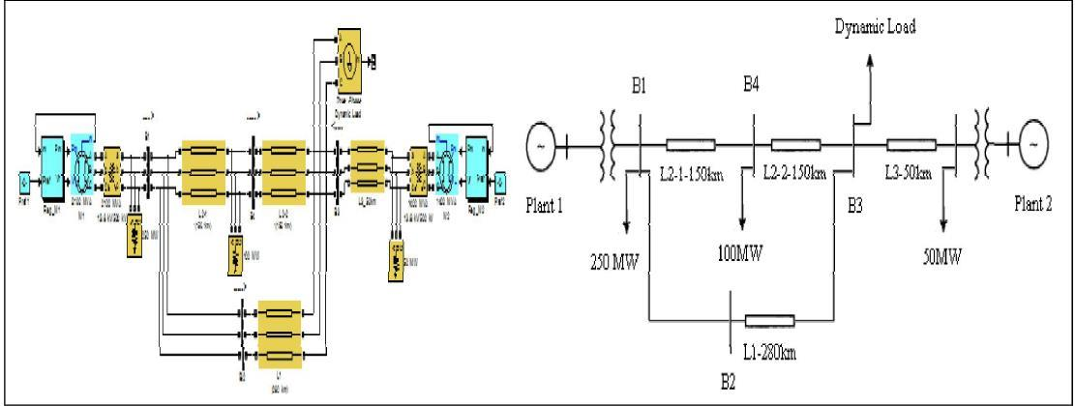
Fig 7.2 Two machine system without sssc

Active And Reactive Power Of Bus3 Without Installation Of Sssc
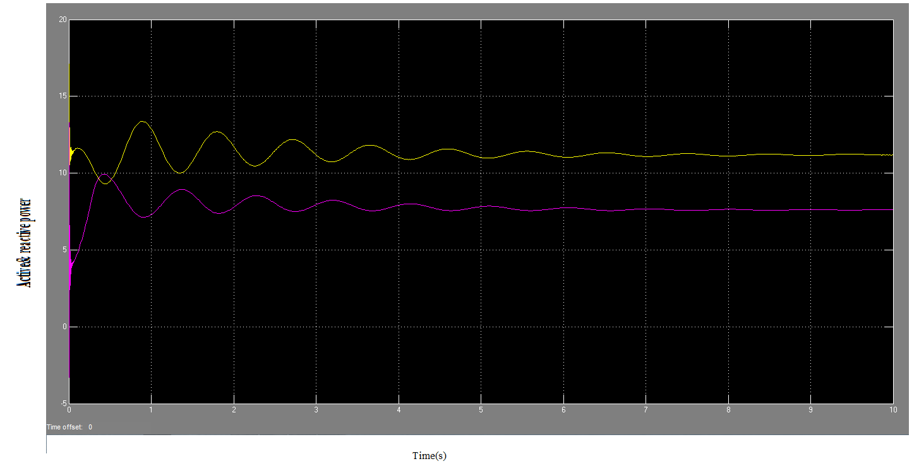
Fig 7.3 Active and reactive power of bus3 without installation of sssc

In the system illustrated at Fig, the energy function is defined as:
This equation can be rewritten as:
The differential calculus can be recombined as the following:
In this express, the first component is the sum power of the generator which is equal to 0. Pi inj and Qi inj are the sum injected active power and sum injected reactive power of each node, and which are equal to 0, too. So the variance ratio of system energy is determined by the last item and can be expressed as :
To damp the power swing, the system energy must be reduced as quickly as possible. So value of SSSC reactance must be modulated properly so that V<0, and its absolute value is the largest. Because the influence of voltage variance always is very larger than that of power angle variance during power oscillations, the component corresponding to voltage can be ignored. Then the control ruler of SSSC can be derived as:
Because the power angle variance between send end and receive end θ12 is positive, the regulation method of SSSC is determined by the sign of θ12
. During power oscillations θ12 and ω12 has the same sign, so the control rulers of SSSC based on ω12 can be derived as:
SSSC must adopt a Bang-Bang operation in terms of formula, and the output must be in phase with the speed deviation between the two groups of machines. This strategy generates the largest damping to the system, so it is a minimum time control strategy.
The differential calculus can be recombined as the following:

Voltage Of Bus-3 Without The Installation Of Sssc
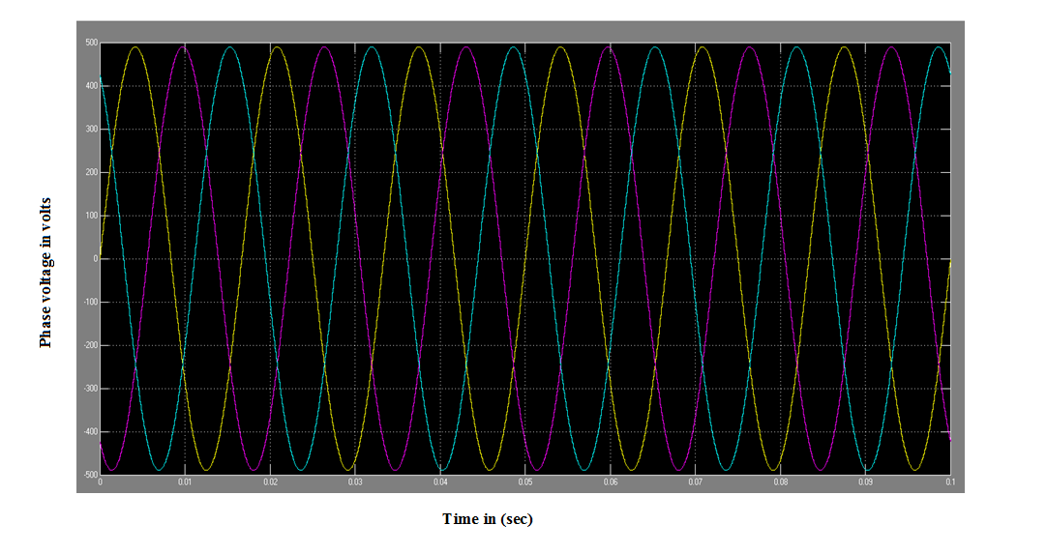
fig 7.4 Voltage of bus-3 without the installation of sssc

Current Of Bus-3 Without The Installation Of Sssc
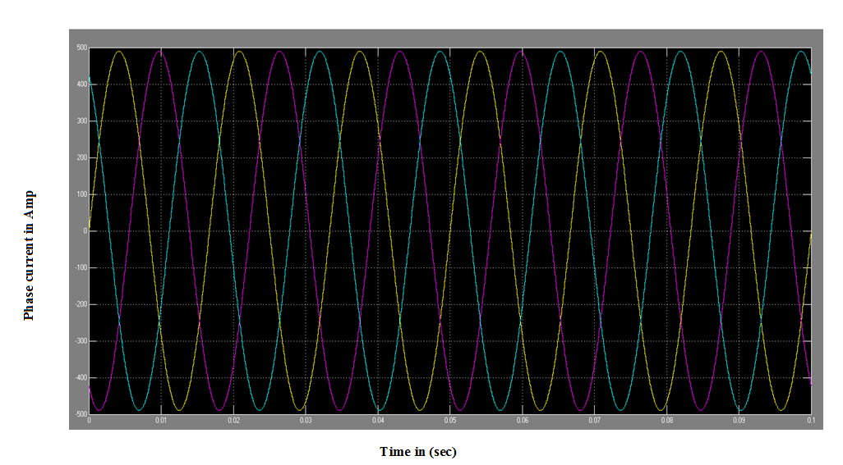
fig 7.5 Current of bus-3 without the installation of sssc
7.2 Two Machine System With Sssc
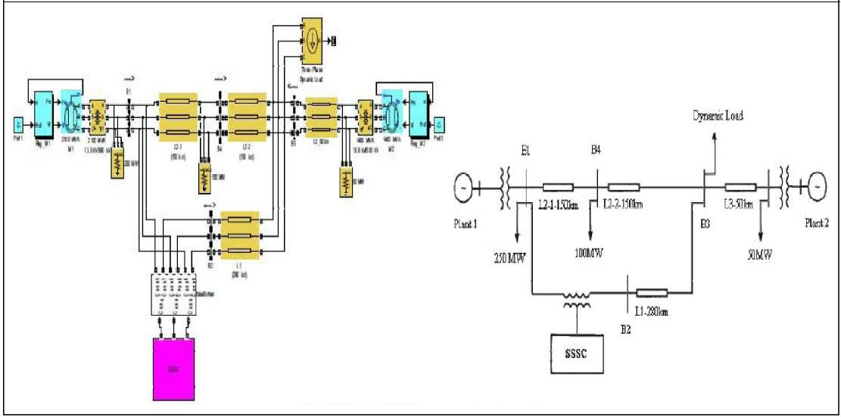
Fig 7.6 Two machine system with SSSC

Active Power Of Bus-3 In The Presence Of Sssc
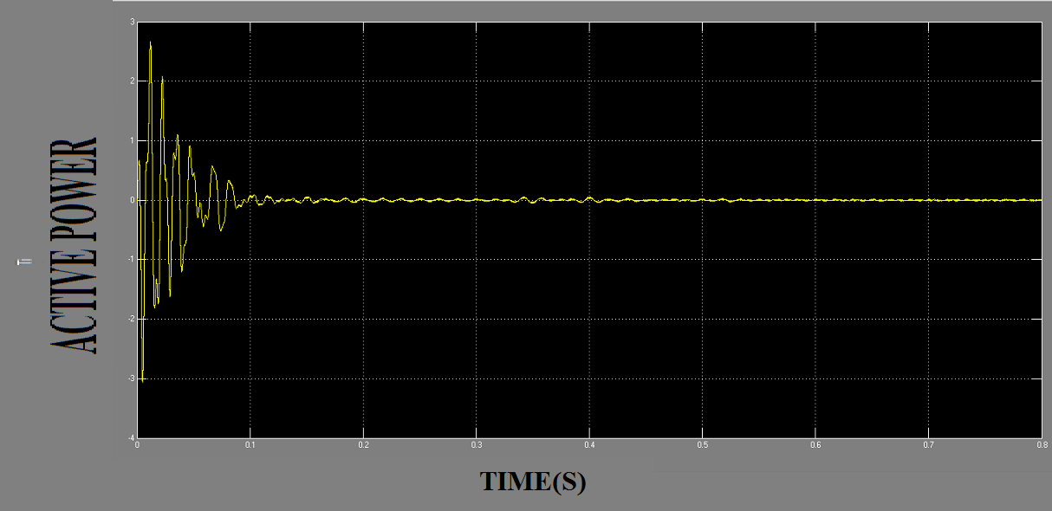
Fig 7.7 Active power of bus-3 in the presence of sssc

Reactive Power Of Bus-3 In The Presence Of Sssc
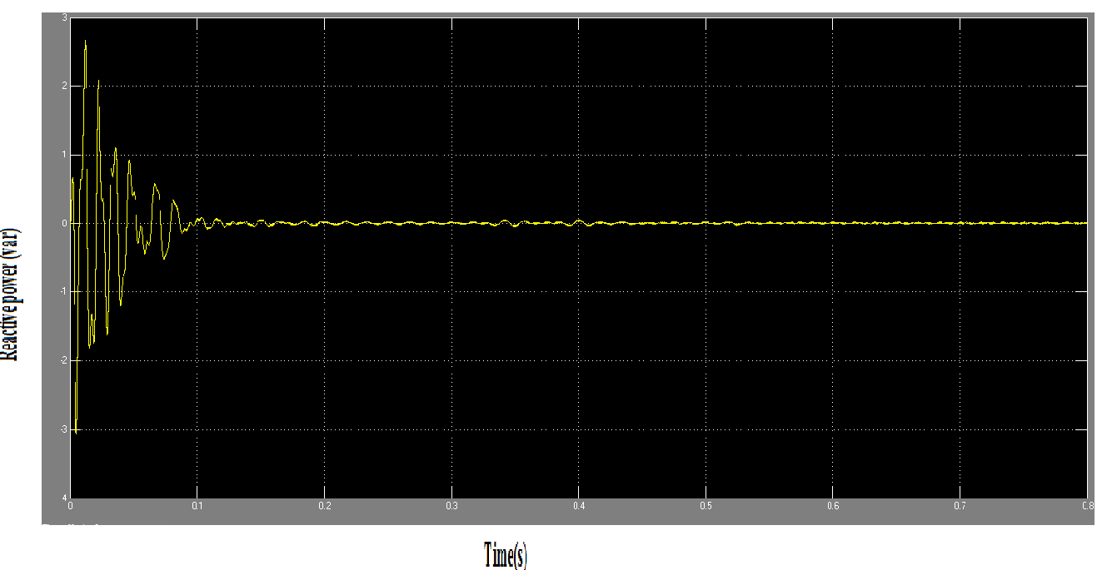
Fig 7.8 Reactive power of bus-3 in the presence of sssc

Current Of Bus-3 In The Presence Of Ssc
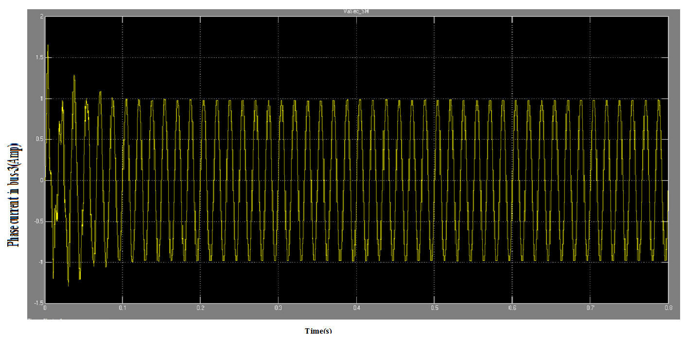
Fig 7.9 Current of bus-3 in the presence of sssc

Simulation Results
Table 7.1 Obtained Result from the simulations
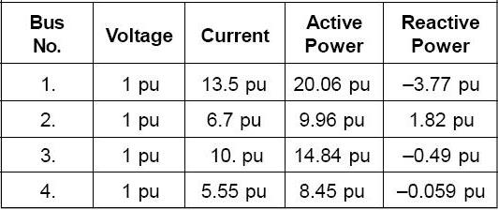

Conclusions
It has been found that the SSSC is capable of controlling the flow of power at a desired point on the transmission line. irrespective of the magnitude and phase of the line current. Based on obtained simulation results the performance of the SSSC has been examined in a simple two-machine system simply on the selected bus-3, and applications of the SSSC will be extended in future to a complex and multi-machine system to investigate the problems related to the various modes of power oscillations in the power system.

REFERENCES
[1] N. G. Hingorani and L. Gyugyi, Understanding FACTS: Concepts and Technology of Flexible AC Transmission System, IEEE Press, 2000.
[2] H.F.Wang, F.J.Swift," A Unified Model for the Analysis of FACTS Devices in Damping Power System Oscillations Part I: Single-machine Infinite-bus Power Systems", IEEE Transactions on Power Delivery, Vol. 12, No. 2, April 1997, pp.941-946.
[3] L. Gyugyi, C.D. Schauder, S.L. Williams, T.R.Rietman, D.R. Torgerson, A. Edris, "The UnifiedPower Flow Controller: A New Approach to PowerTransmission Control", IEEE Trans., 1995, pp. 1085-1097.
[4] Wolanki, F. D. Galiana, D. McGillis and G. Joos, “Mid-Point Sitting of FACTS Devices in Transmission Lines,” IEEE Transactions on Power Delivery, vol. 12, No. 4, 1997, pp. 1717-1722.
[5] M. Noroozian, L. Angquist, M. Ghandari, and G. Anderson, “Use of SSSC for optimal power flow control”, IEEE Trans. on Power Systems, vol. 12, no. 4, 1997, pp. 1629–1634.
[6] A Nabavi-Niaki and M R Iravani. ‘Steady-state and Dynamic Models of Unified Power Flow Controller (SSSC) for Power System Studies.’ IEEE Transactions on Power Systems, vol 11, 1996, p 1937.
[7] K S Smith, L Ran, J Penman. ‘Dynamic Modelling of a Unified Power Flow Controller.’ IEE Proceedings-C, vol 144, 1997, pp.7. [8] H F Wang. ‘Damping Function of Unified Power Flow Controller.’ IEEE Proceedings-C, vol 146, no 1, January 1999, p 81.
[9] H. F. Wang, F. J. Swift, “A Unified Model for the Analysis of FACTS Devices in Damping Power System Oscillations Part I: Single-machine Infinite-bus Power Systems,” IEEE Transactions on Power Delivery, Vol. 12, No. 2, April, 1997, pp. 941-946.
[10]P. Kundur,"Power System Stability and Control",McGraw-Hill.
[11] M. Banejad, A. M. Dejamkhooy , N. Talebi, " PI Logic Based SSSC Controller for Damping Low Frequency Oscillations of Power Systems", 2nd IEEE International Conference on Power and Energy, 2008, pp. 85-88.
[12] P.K., Dash, S. Mishra, G. Panda, , "Damping multimodal power system oscillation using a hybrid PI controller for series connected FACTS devices", IEEE Trans. on Power Systems, Vol. 15, 2000, pp. 1360 -1366.
[13] A. Oudalov, R. Cherkaoui, A.J. Germond, "Application of PI logic techniques for the coordinated power flow control by multiple series FACTS devices", IEEE Power Engineering Society Iternational Conference, 2001, pp. 74 – 80.

